Project Narrative – CCBHC Expansion Grant
Use this tool to help you outline the requirements to complete your CCBHC grant application.
Section A: Population of Focus and Statement of Need
- Identify your population(s) of focus and the geographic catchment area where services will be delivered.
Click here to enter notes.

- Describe other behavioral health care services currently available in the service area including whether they also serve your target population.
Click here to enter notes.

- Describe the nature of the problem, including service gaps, and document the unmet mental health needs in the community (i.e., current prevalence rates or incidence data) for the population(s) of focus.

Click here to enter notes.

Include:
• The extent of the need • Barriers to care • Gaps in service • Health disparities evident
You should utilize current quantitative data for this section. To the extent available, use local data to identify service gaps and needs, supplemented with state and national data. Always remember to identify the source of your data.
Sources of local data could include:
• State and county public agencies • School or court systems • Community health assessments

Some sources of national data could include:
• County Health Rankings • US Census Bureau • SAMHSA Data • CDC Health Data

Section B: Proposed Implementation Approach
- Describe the goals and measurable objectives of the proposed project and align them with your Statement of Need.
Click here to enter notes.

Effective goals should:
-address outcomes, not how outcomes will be achieved
-describe the behavior or condition in the community expected to change
-describe who will be affected by the project
-lead clearly to one or more measurable results
Effective objectives should:
-be clear and leave no room for interpretation.
SMART is a helpful acronym for developing objectives that are specific, measurable, achievable, realistic, and time-bound:
Specific – the who and what of program activities.
Measurable- how much change is expected
Achievable – attainable within a time frame and with available program resources
Realistic – within the scope of the project and propose reasonable programmatic steps.
Time-bound – indicate when objective will be measured or when objective will be met.

Complete the following table:
You are expected to achieve the numbers that are proposed.
Number of Unduplicated Individuals to be Served with Grant Funds
Year 1 | Year 2 | Total
Click here to enter notes. | Click here to enter notes. | Click here to enter notes.

- Describe how you will implement all the required activities for the grant project:

Click here to enter notes.

- Describe your ability to meet CCBHC criteria based on the Criteria Compliance Checklist.
If you are not currently certified, describe how you will become certified within four months following the award.
View the detailed CCBHC criteria list from SAMHSA and utilize our fillable checklist to help you draft your response.

Click here to enter notes.

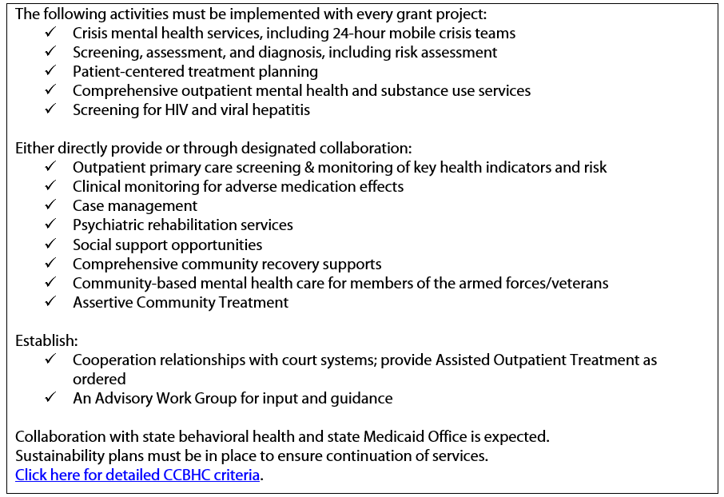

- Provide a chart or graph depicting a realistic timeline for the entire two years of the project period showing dates, key activities, and responsible staff.
These key activities must include the required activities of the grant project. If you are not a CCBHC and are working towards certification, there is a window of implementation to begin delivering services. For previous grant cycles, this was within four months after the award. Regardless, activities should begin as soon as possible.
SAMHSA offers the following suggestions for your timeline:
- Make a list of all the required activities and include them in the timeline. Don’t forget to include the submission of required reports.
- Keep the timeline simple. If a very complex timeline is provided it is often difficult for reviewers to clearly understand when the activities will be implemented.
- Make sure you include activities related to data collection and performance measurement.
- For responsible staff, put the position title of the person who will be responsible, not just their name.
Make sure:
- your timeline covers all years and applicable start dates for the project period
- use a readable font
- include the specific staff members who are responsible, even if it is all of the staff
-your timeline is REALISTIC and allows time for recruiting, hiring and training as needed.
Below are some potential template examples:
Goals | Key Activities | Responsible Staff | Start Date/Completion Date
Goal 1 | 1.
 | 2.
Goal 2 | 1.
 | 2.

Year 1 (Months) |  |  |  |  |  |  |  |  |  |  |  |  | Year 2
Key Activity & Responsible Staff | 1 | 2 | 3 | 4 | 5 | 6 | 7 | 8 | 9 | 10 | 11 | 12 | 13-18 mo. | 19-24 mo.
START- UP
Recruit New Staff (PD) | X
Hire New Staff (PD) |  | X | X
IMPLEMENTATION
Service Area Outreach (PC) | X |  | X |  | X |  | X |  | X |  | X |  | X | X

Key: (PD) Project Director (PC) Project Coordinator (E) Evaluator (DM) Data Manager

Section C: Proposed Evidence-Based Service/Practice

- Identify the Evidence-Based Practice(s) (EBPs) that will be used. Discuss how each EBP chosen is appropriate for your population(s) of focus and the outcomes you want to achieve. Describe any modifications that will be made to the EBP(s) and the reason the modifications are necessary.

This description should reference why each EBP is appropriate for the problem area you plan to address and your population(s) of focus; specific information about modifications (if any) and justification for those modifications.
Make sure to include how you plan to monitor the implementation of the EBPs to ensure adherence to EBP guidelines.

Click here to enter notes.

Section D: Staff and Organizational Experience
Describe the experience of your organization with similar projects and/or providing services to the population(s) of focus for this grant. Identify other organization(s) that you will partner with in the proposed project, including their experience providing services to the population(s) of focus, and their specific roles and responsibilities for this project.
You’ll need to get letters of commitment for partnering organizations. Reach out earlier rather than later to make sure those letters are ready when the grant application is due.
- Provide a complete list of staff positions for the project, including:
Key Personnel (Project Director and Evaluator) & other significant personnel (e.g., Clinic Medical Director, Clinic Director of Continuous Quality Improvement). Describe the role of each and their level of effort and qualifications.

Click here to enter notes.

Make sure you include:
-Staff experiences providing services to the populations of focus and familiarity with culture(s) and/or language(s).
-Linkages of your organization to population(s) of focus and ties to community-based organizations that are rooted in the culture/languages of those populations.
-Capability and experience of partners and partner organizations
-how you will ensure input of consumers, clients, and family members of consumers in grant project.

Section E: Data Collection and Performance Measurement

Provide specific information about how you will collect the required data for this program and how such data will be utilized to manage, monitor, and enhance the program.

Click here to enter notes.

REA can help! We can help to make sure that your data collection and measurement processes align with requirements of the grant and help you to successfully track outcomes for program impact.

We offer the following grant writing assistance at no cost to you:
- A comprehensive overall grant review to assure SAMHSA formatting and validation requirements are met
- Support and review of best practices for creation of goals and measurable objectives

- Writing of narrative related to data collection and evaluation requirements for completion of the grant application.

Please feel free to contact us by emailing us directly, giving us a call at (616) 954-5293, or scheduling a virtual meeting at your convenience.

